The feature maps have been plotted for each case. The circles are the data points.

Plots:

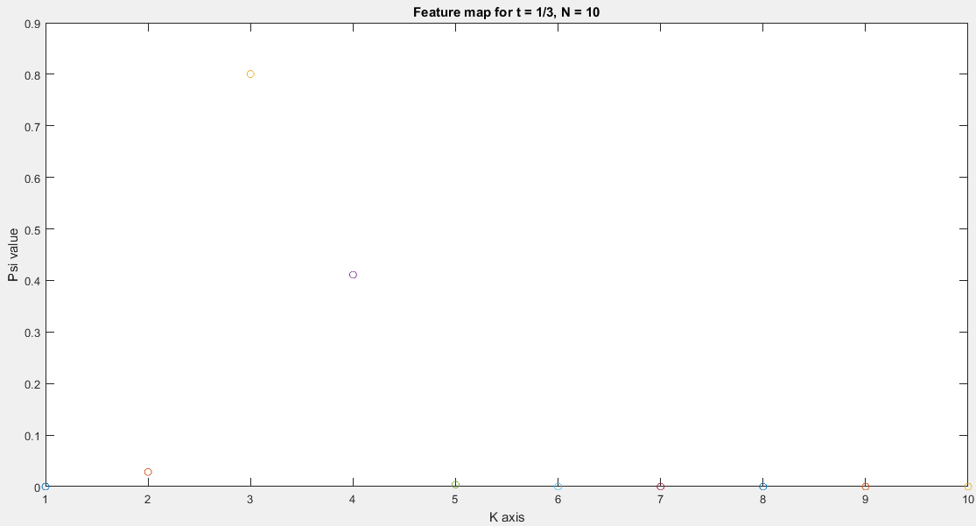

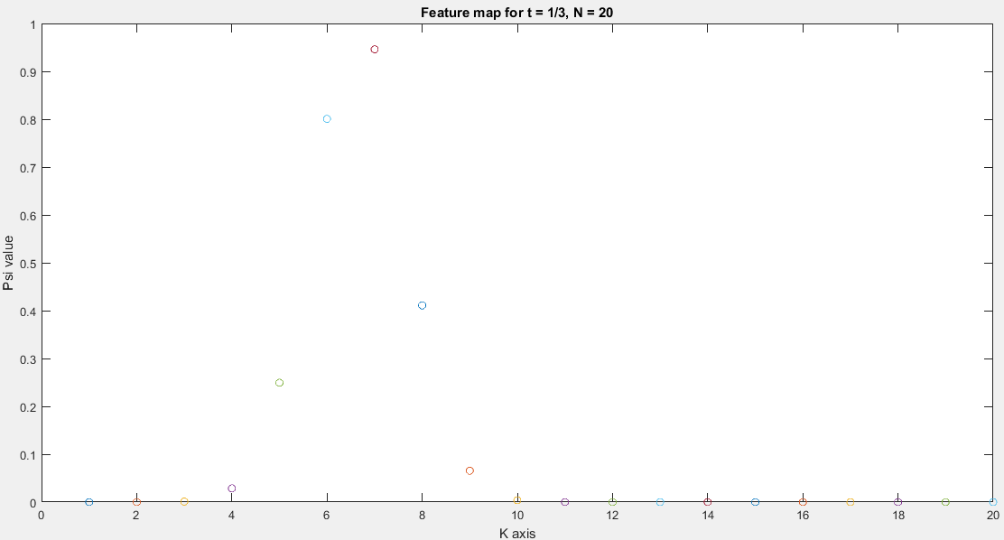

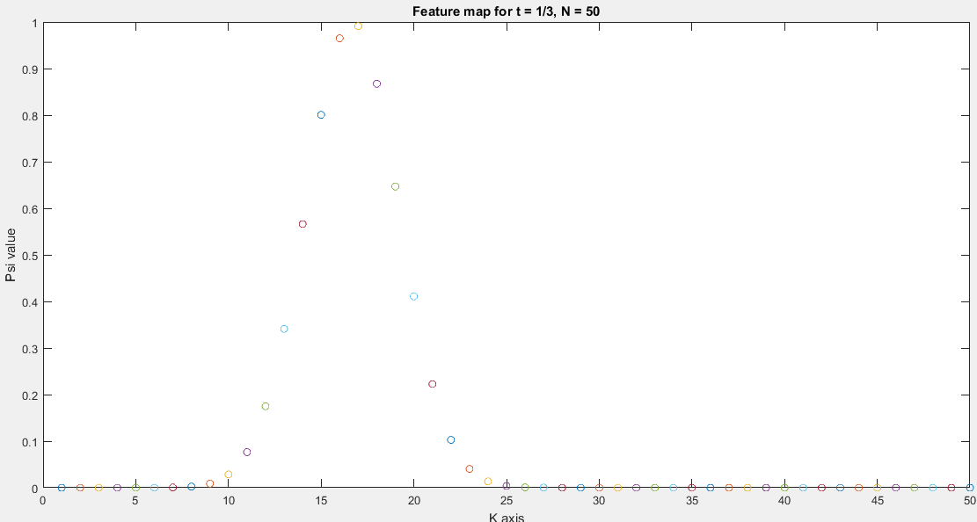

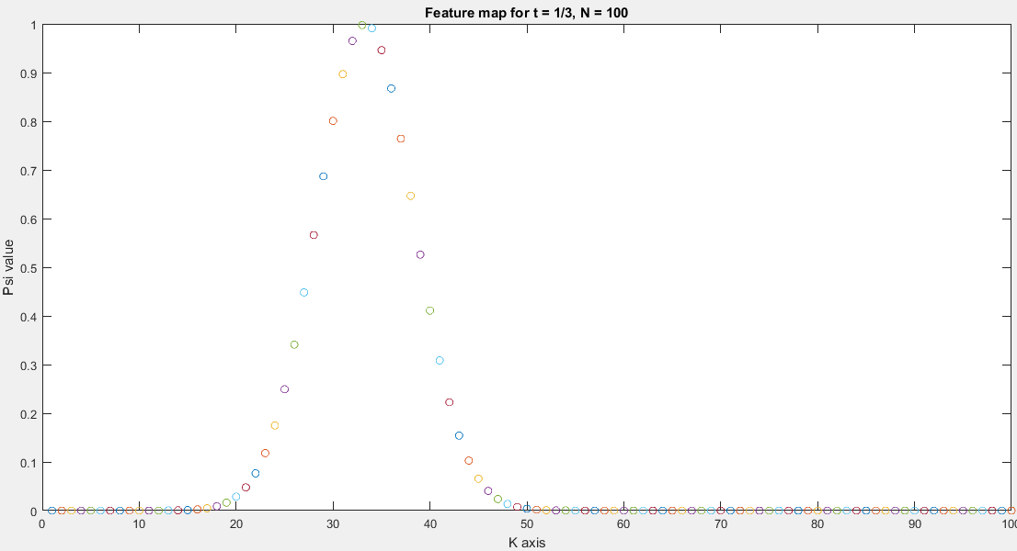

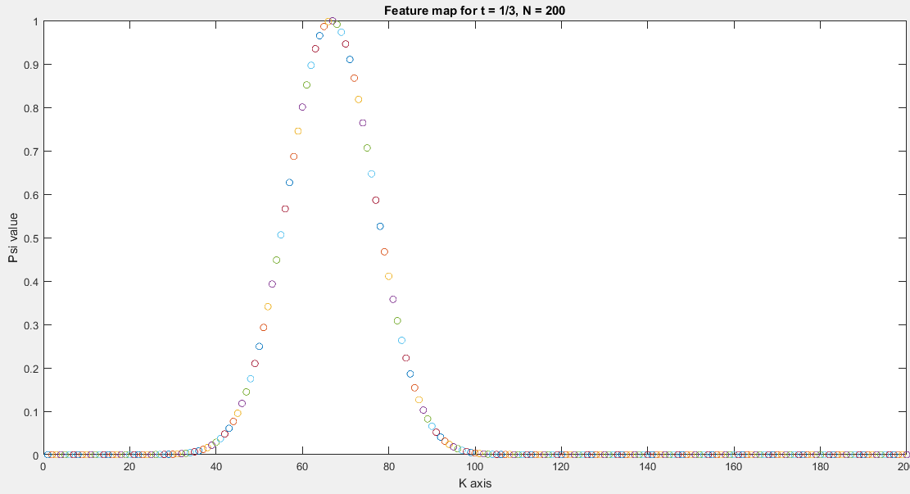

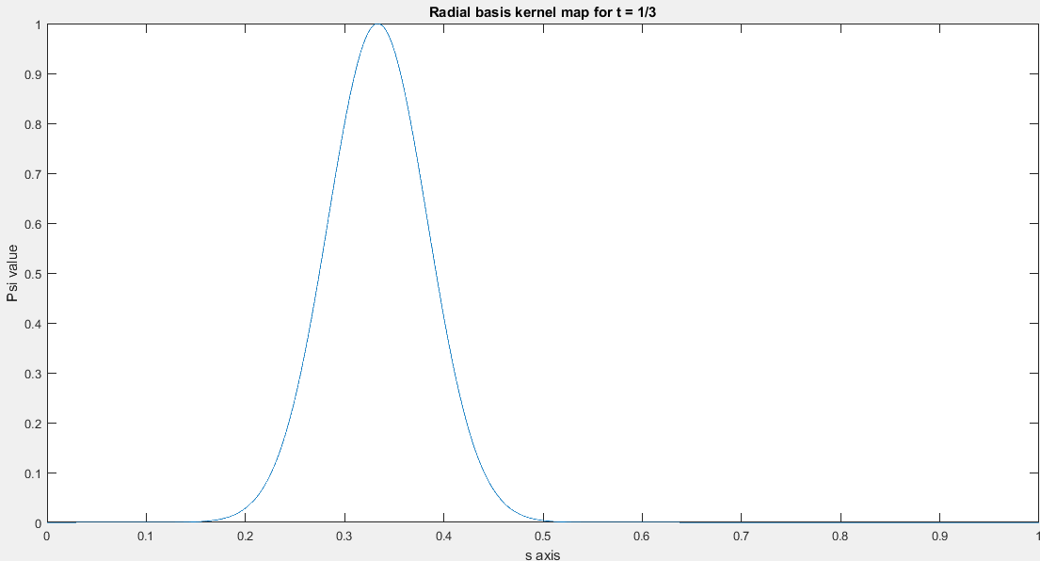

Comments:

In the case of kernel regression, the tm (in the reconstruction formula) need not be spaced uniformly. They can be at any point as desired. Thus, kernel regression can be changed according to the data that we are trying to fit. But in the non-linear regression case, they are placed in a uniform manner. One can indeed get the non-linear regression basis by setting the kernel basis tm at uniform intervals. Thus, as we can see from the plots, the bump basis vectors and the radial basis kernel map are of the same form.

Code:

clear all;

close all;

t = 1/3;

N = [10, 20, 50, 100, 200];

for i = 1:5

figure;

for k = 1:N(i)

psit(k) = exp(-200\*((t-(k/N(i)))^2));

plot(k, psit(k),'o');

xlabel ('K axis');

ylabel ('Psi value');

hold on;

end

title(['Feature map for t = 1/3, N = ' num2str(k) '']);

end

figure;

s = linspace(0,1,5000);

plot(s, exp(-200\*((s-(1/3)).^2)));

xlabel ('s axis');

title('Radial basis kernel map for t = 1/3');

ylabel ('Psi value');